| Please choose a lesson, or type 0 to return to course menu.

1: Principles of Analytic Graphs 2: Exploratory Graphs 3: Graphics Devices in R

4: Plotting Systems 5: Base Plotting System 6: Lattice Plotting System

7: Working with Colors 8: GGPlot2 Part1 9: GGPlot2 Part2

10: GGPlot2 Extras 11: Hierarchical Clustering 12: K Means Clustering

13: Dimension Reduction 14: Clustering Example 15: CaseStudy

Selection: 7

| Attemping to load lesson dependencies...

| Package ‘jpeg’ loaded correctly!

| Package ‘RColorBrewer’ loaded correctly!

| Package ‘datasets’ loaded correctly!

| | 0%

| Working_with_Colors. (Slides for this and other Data Science courses may be found at github

| https://github.com/DataScienceSpecialization/courses/. If you care to use them, they must be downloaded as a

| zip file and viewed locally. This lesson corresponds to 04_ExploratoryAnalysis/Colors.)

...

|= | 1%

| This lesson is about using colors in R. It really supplements the lessons on plotting with the base and

| lattice packages which contain functions that are able to take the argument col. We'll discuss ways to set

| this argument more colorfully.

...

|=== | 3%

| Of course, color choice is secondary to your data and how you analyze it, but effectively using colors can

| enhance your plots and presentations, emphasizing the important points you're trying to convey.

...

|==== | 4%

| The motivation for this lesson is that the default color schemes for most plots in R are not optimal.

| Fortunately there have been recent developments to improve the handling and specification of colors in plots

| and graphs. We'll cover some functions in R as well as in external packages that are very handy. If you know

| how to use some of these then you'll have more options when you create your displays.

...

|====== | 6%

| We'll begin with a motivating example - a typical R plot using 3 default colors.

...

|======= | 7%

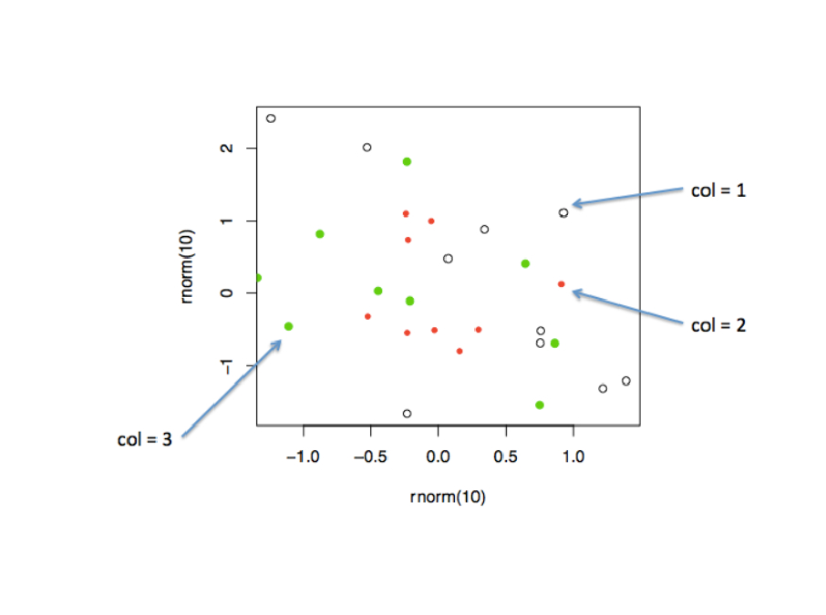

| According to the plot, what is color 2?

1: Empty black circles

2: Red

3: Blue

4: Green

Selection: 2

| That's the answer I was looking for.

|========= | 9%

| So these are the first 3 default values. If you were plotting and just specified col=c(1:3) as one of your

| arguments, these are colors you'd get. Maybe you like them, but they might not be the best choice for your

| application.

...

|========== | 10%

| To show you some options, here's a display of two color palettes that come with the grDevices package

| available to you. The left shows you some colors from the function heat.colors. Here low values are

| represented in red and as the values increase the colors move through yellow towards white. This is

| consistent with the physical properties of fire. The right display is from the function topo.colors which

| uses topographical colors ranging from blue (low values) towards brown (higher values).

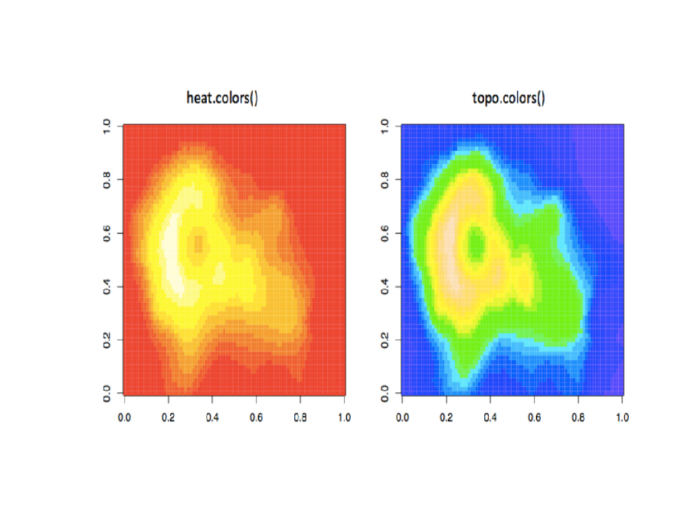

...

|============ | 12%

| So we'll first discuss some functions that the grDevices package offers. The function colors() lists the

| names of 657 predefined colors you can use in any plotting function. These names are returned as strings.

| Run the R command sample with colors() as its first argument and 10 as its second to give you an idea of the

| choices you have.

> sample(colors(), 10)

[1] "moccasin" "burlywood" "thistle" "gray54" "grey45" "lemonchiffon4"

[7] "hotpink1" "gray79" "turquoise1" "mistyrose3"

| You're the best!

|============= | 13%

| We see a lot of variety in the colors, some of which are names followed by numbers indicating that there are

| multiple forms of that particular color.

...

|=============== | 14%

| So you're free to use any of these 600+ colors listed by the colors function. However, two additional

| functions from grDevices, colorRamp and colorRampPalette, give you more options. Both of these take color

| names as arguments and use them as "palettes", that is, these argument colors are blended in different

| proportions to form new colors.

...

|================ | 16%

| The first, colorRamp, takes a palette of colors (the arguments) and returns a function that takes values

| between 0 and 1 as arguments. The 0 and 1 correspond to the extremes of the color palette. Arguments between

| 0 and 1 return blends of these extremes.

...

|================== | 17%

| Let's see what this means. Assign to the variable pal the output of a call to colorRamp with the single

| argument, c("red","blue").

> pal <- colorRamp(c("red", "blue"))

| Perseverance, that's the answer.

|=================== | 19%

| We don't see any output, but R has created the function pal which we can call with a single argument between

| 0 and 1. Call pal now with the argument 0.

> pal(0)

[,1] [,2] [,3]

[1,] 255 0 0

| All that hard work is paying off!

|==================== | 20%

| We see a 1 by 3 array with 255 as the first entry and 0 in the other 2. This 3 long vector corresponds to

| red, green, blue (RGB) color encoding commonly used in televisions and monitors. In R, 24 bits are used to

| represent colors. Think of these 24 bits as 3 sets of 8 bits, each of which represents an intensity for one

| of the colors red, green, and blue.

...

|====================== | 22%

| The 255 returned from the pal(0) call corresponds to the largest possible number represented with 8 bits, so

| the vector (255,0,0) contains only red (no green or blue), and moreover, it's the highest possible value of

| red.

...

|======================= | 23%

| Given that you created pal with the palette containing "red" and "blue", what color do you think will be

| represented by the vector that pal(1) returns? Recall that pal will only take arguments between 0 and 1, so

| 1 is the largest argument you can pass it.

1: yellow

2: green

3: red

4: blue

Selection: 4

| You got it!

|========================= | 25%

| Check your answer now by calling pal with the argument 1.

> pal(1)

[,1] [,2] [,3]

[1,] 0 0 255

| Perseverance, that's the answer.

|========================== | 26%

| You see the vector (0,0,255) which represents the highest intensity of blue. What vector do you think the

| call pal(.5) will return?

1: (255,0,255)

2: (255,255,255)

3: (0,255,0)

4: (127.5,0,127.5)

Selection: 3

| Keep trying!

| The correct answer should be halfway between (255,0,0) and (0,0,255). Which is the only choice that is the

| average (mean) of these two?

1: (127.5,0,127.5)

2: (255,255,255)

3: (0,255,0)

4: (255,0,255)

Selection: 1

| Your dedication is inspiring!

|============================ | 28%

| The function pal can take more than one argument. It returns one 3-long (or 4-long, but more about this

| later) vector for each argument. To see this in action, call pal with the argument seq(0,1,len=6).

> pal(seq(0, 1, len = 6))

[,1] [,2] [,3]

[1,] 255 0 0

[2,] 204 0 51

[3,] 153 0 102

[4,] 102 0 153

[5,] 51 0 204

[6,] 0 0 255

| You are amazing!

|============================= | 29%

| Six vectors (each of length 3) are returned. The i-th vector is identical to output that would be returned

| by the call pal(i/5) for i=0,...5. We see that the i-th row (for i=1,...6) differs from the (i-1)-st row in

| the following way. Its red entry is 51 = 255/5 points lower and its blue entry is 51 points higher.

...

|=============================== | 30%

| So pal creates colors using the palette we specified when we called colorRamp. In this example none of pal's

| outputs will ever contain green since it wasn't in our initial palette.

...

|================================ | 32%

| We'll turn now to colorRampPalette, a function similar to colorRamp. It also takes a palette of colors and

| returns a function. This function, however, takes integer arguments (instead of numbers between 0 and 1) and

| returns a vector of colors each of which is a blend of colors of the original palette.

...

|================================== | 33%

| The argument you pass to the returned function specifies the number of colors you want returned. Each

| element of the returned vector is a 24 bit number, represented as 6 hexadecimal characters, which range from

| 0 to F. This set of 6 hex characters represents the intensities of red, green, and blue, 2 characters for

| each color.

...

|=================================== | 35%

| To see this better, assign to the variable p1 the output of a call to colorRampPalette with the single

| argument, c("red","blue"). We'll compare it to our experiments using colorRamp.

> p1 <- colorRampPalette(c("red", "blue"))

| You got it!

|===================================== | 36%

| Now call p1 with the argument 2.

> p1(2)

[1] "#FF0000" "#0000FF"

| You are really on a roll!

|====================================== | 38%

| We see a 2-long vector is returned. The first entry FF0000 represents red. The FF is hexadecimal for 255,

| the same value returned by our call pal(0). The second entry 0000FF represents blue, also with intensity

| 255.

...

|======================================== | 39%

| Now call p1 with the argument 6. Let's see if we get the same result as we did when we called pal with the

| argument seq(0,1,len=6).

> p1(6)

[1] "#FF0000" "#CC0033" "#990066" "#650099" "#3200CC" "#0000FF"

| Perseverance, that's the answer.

|========================================= | 41%

| Now we get the 6-long vector (FF0000, CC0033, 990066, 650099, 3200CC, 0000FF). We see the two ends (FF0000

| and 0000FF) are consistent with the colors red and blue. How about CC0033? Type 0xcc or 0xCC at the command

| line to see the decimal equivalent of this hex number. You must include the 0 before the x to specify that

| you're entering a hexadecimal number.

> 0xcc

[1] 204

| You nailed it! Good job!

|========================================== | 42%

| So 0xCC equals 204 and we can easily convert hex 33 to decimal, as in 0x33=3*16+3=51. These were exactly the

| numbers we got in the second row returned from our call to pal(seq(0,1,len=6)). We see that 4 of the 6

| numbers agree with our earlier call to pal. Two of the 6 differ slightly.

...

|============================================ | 43%

| We can also form palettes using colors other than red, green and blue. Form a palette, p2, by calling

| colorRampPalette with the colors "red" and "yellow". Remember to concatenate them into a single argument.

> p2 <- colorRampPalette(c("red", "yellow"))

| You are really on a roll!

|============================================= | 45%

| Now call p2 with the argument 2. This will show us the two extremes of the blends of colors we'll get.

> p2(2)

[1] "#FF0000" "#FFFF00"

| Keep up the great work!

|=============================================== | 46%

| Not surprisingly the first color we see is FF0000, which we know represents red. The second color returned,

| FFFF00, must represent yellow, a combination of full intensity red and full intensity green. This makes

| sense, since yellow falls between red and green on the color wheel as we see here. (We borrowed this image

| from lucaskrech.com.)

...

|================================================ | 48%

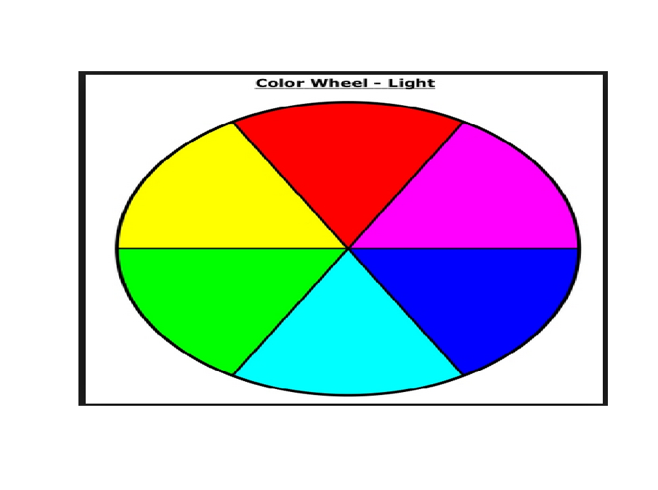

| Let's now call p2 with the argument 10. This will show us how the two extremes, red and yellow, are blended

| together.

> p2(10)

[1] "#FF0000" "#FF1C00" "#FF3800" "#FF5500" "#FF7100" "#FF8D00" "#FFAA00" "#FFC600" "#FFE200" "#FFFF00"

| Great job!

|================================================== | 49%

| So we see the 10-long vector. For each element, the red component is fixed at FF, and the green component

| grows from 00 (at the first element) to FF (at the last).

...

|=================================================== | 51%

| This is all fine and dandy but you're probably wondering when you can see how all these colors show up in a

| display. We copied some code from the R documentation pages (color.scale if you're interested) and created a

| function for you, showMe. This takes as an argument, a color vector, which as you know, is precisely what

| calls to p1 and p2 return to you. Call showMe now with p1(20).

> showMe(p1(20))

| You got it!

|===================================================== | 52%

| We see the interpolated palette here. Low values in the lower left corner are red and as you move to the

| upper right, the colors move toward blue. Now call showMe with p2(20) as its argument.

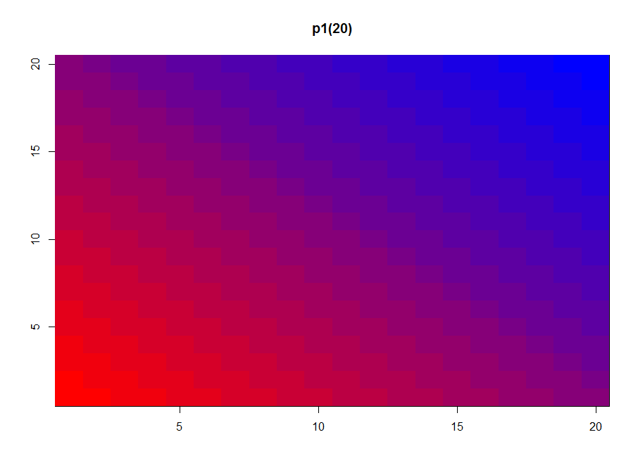

> showMe(p2(20))

| You got it!

|====================================================== | 54%

| Here we see a similar display, the colors moving from red to yellow, the base colors of our p2 palette. For

| fun, see what p2(2) looks like using showMe.

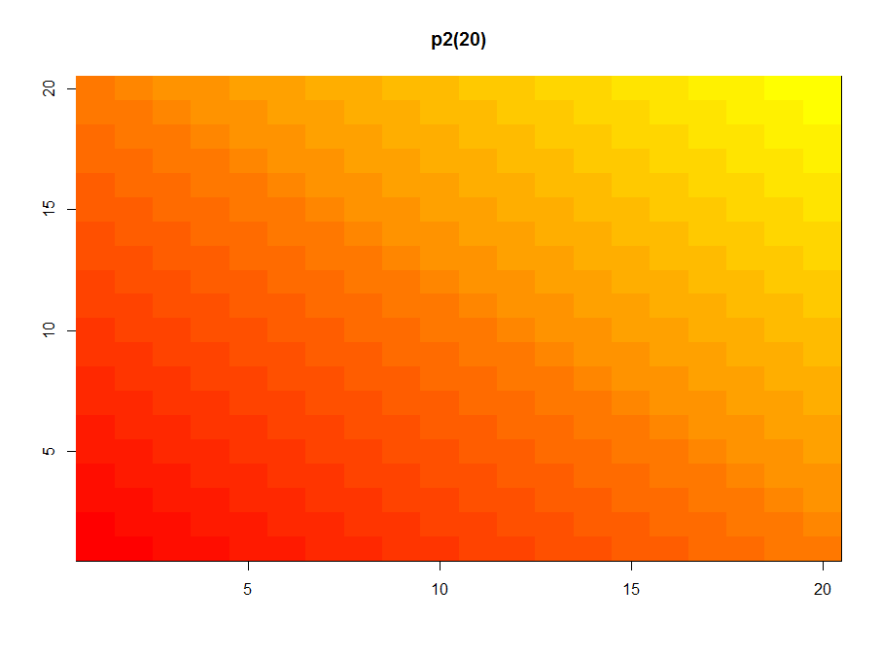

> showMe(p2(2))

| Keep up the great work!

|======================================================== | 55%

| A much more basic pattern, simple but elegant.

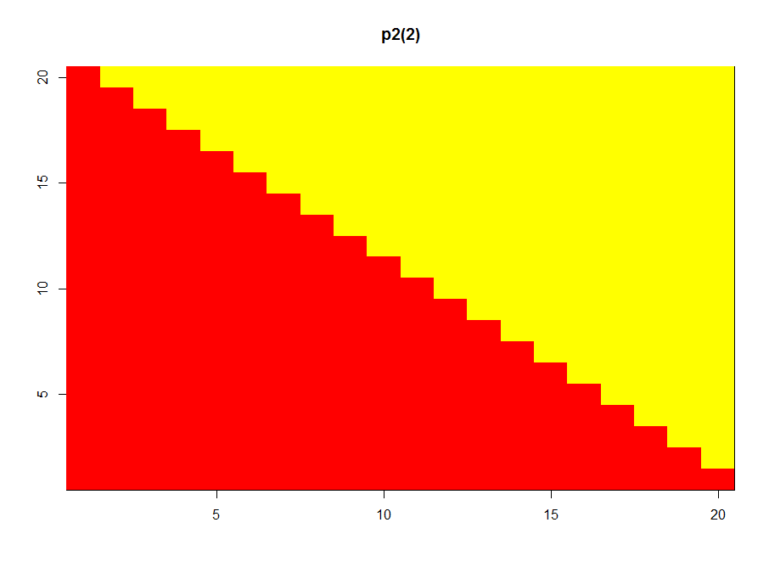

...

|========================================================= | 57%

| We mentioned before that colorRamp (and colorRampPalette) could return a 3 or 4 long vector of colors. We

| saw 3-long vectors returned indicating red, green, and blue intensities. What would the 4th entry be?

...

|=========================================================== | 58%

| We'll answer this indirectly. First, look at the function p1 that colorRampPalette returned to you. Just

| type p1 at the command prompt.

> p1

function (n)

{

x <- ramp(seq.int(0, 1, length.out = n))

if (ncol(x) == 4L)

rgb(x[, 1L], x[, 2L], x[, 3L], x[, 4L], maxColorValue = 255)

else rgb(x[, 1L], x[, 2L], x[, 3L], maxColorValue = 255)

}

<bytecode: 0x00000000176b10e8>

<environment: 0x0000000018eed278>

| Keep up the great work!

|============================================================ | 59%

| We see that p1 is a short function with one argument, n. The argument n is used as the length in a call to

| the function seq.int, itself an argument to the function ramp. We can infer that ramp is just going to

| divide the interval from 0 to 1 into n pieces.

...

|============================================================= | 61%

| The heart of p1 is really the call to the function rgb with either 4 or 5 arguments. Use the ?fun construct

| to look at the R documentation for rgb now.

> ?rgb

| That's correct!

|=============================================================== | 62%

| We see that rgb is a color specification function that can be used to produce any color with red, green,

| blue proportions. We see the maxColorValue is 1 by default, so if we called rgb with values for red, green

| and blue, we would specify numbers at most 1 (assuming we didn't change the default for maxColorValue).

| According to the documentation, what is the maximum number of arguments rgb can have?

1: 5

2: 4

3: 6

4: 3

Selection: 3

| Nice work!

|================================================================ | 64%

| So the fourth argument is alpha which can be a logical, i.e., either TRUE or FALSE, or a numerical value.

| Create the function p3 now by calling colorRampPalette with the colors blue and green (remember to

| concatenate them into a single argument) and setting the alpha argument to .5.

> p3 <- colorRampPalette(c("blue", "green"), alpha = .5)

| All that hard work is paying off!

|================================================================== | 65%

| Now call p3 with the argument 5.

> p3(5)

[1] "#0000FFFF" "#003FBFFF" "#007F7FFF" "#00BF3FFF" "#00FF00FF"

| You're the best!

|=================================================================== | 67%

| We see that in the 5-long vector that the call returned, each element has 32 bits, 4 groups of 8 bits each.

| The last 8 bits represent the value of alpha. Since it was NOT ZERO in the call to colorRampPalette, it gets

| the maximum FF value. (The same result would happen if alpha had been set to TRUE.) When it was 0 or FALSE

| (as in previous calls to colorRampPalette) it was given the value 00 and wasn't shown. The leftmost 24 bits

| of each element are the same RGB encoding we previously saw.

...

|===================================================================== | 68%

| So what is alpha? Alpha represents an opacity level, that is, how transparent should the colors be. We can

| add color transparency with the alpha parameter to calls to rgb. We haven't seen any examples of this yet,

| but we will now.

...

|====================================================================== | 70%

| We generated 1000 random normal pairs for you in the variables x and y. We'll plot them in a scatterplot by

| calling plot with 4 arguments. The variables x and y are the first 2. The third is the print character

| argument pch. Set this equal to 19 (filled circles). The final argument is col which should be set equal to

| a call to rgb. Give rgb 3 arguments, 0, .5, and .5.

> plot(x, y, pch = 19, col = rgb(0, .5, .5))

| You nailed it! Good job!

|======================================================================== | 71%

| Well this picture is okay for a scatterplot, a nice mix of blue and green, but it really doesn't tell us too

| much information in the center portion, since the points are so thick there. We see there are a lot of

| points, but is one area more filled than another? We can't really discriminate between different point

| densities. This is where the alpha argument can help us. Recall your plot command (use the up arrow) and add

| a 4th argument, .3, to the call to rgb. This will be our value for alpha.

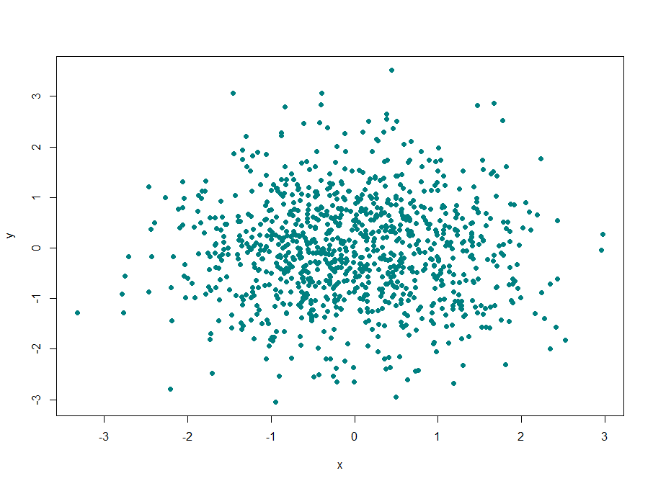

> plot(x, y, pch = 19, col = rgb(0, .5, .5, .3))

| You got it right!

|========================================================================= | 72%

| Clearly this is better. It shows us where, specifically, the densest areas of the scatterplot really are.

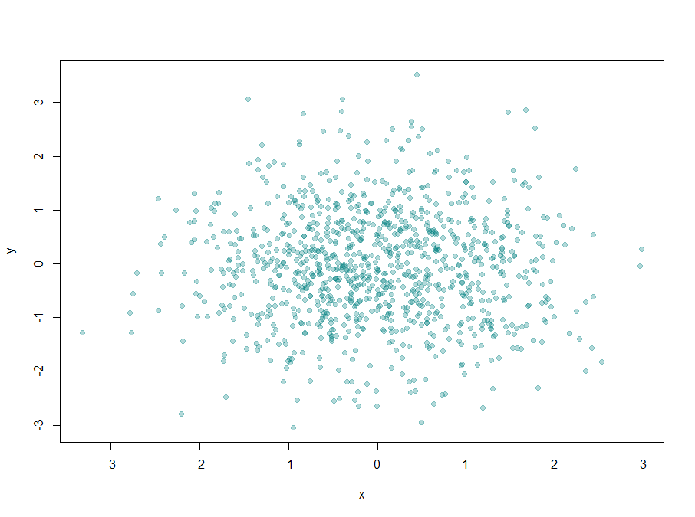

...

|=========================================================================== | 74%

| Our last topic for this lesson is the RColorBrewer Package, available on CRAN, that contains interesting and

| useful color palettes, of which there are 3 types, sequential, divergent, and qualitative. Which one you

| would choose to use depends on your data.

...

|============================================================================ | 75%

| Here's a picture of the palettes available from this package. The top section shows the sequential palettes

| in which the colors are ordered from light to dark. The divergent palettes are at the bottom. Here the

| neutral color (white) is in the center, and as you move from the middle to the two ends of each palette, the

| colors increase in intensity. The middle display shows the qualitative palettes which look like collections

| of random colors. These might be used to distinguish factors in your data.

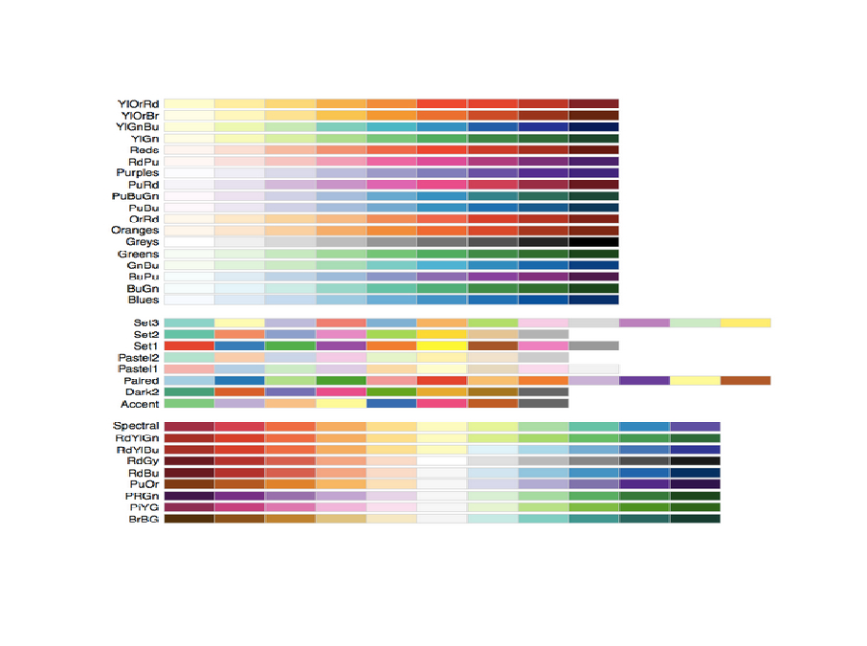

...

|============================================================================== | 77%

| These colorBrewer palettes can be used in conjunction with the colorRamp() and colorRampPalette() functions.

| You would use colors from a colorBrewer palette as your base palette,i.e., as arguments to colorRamp or

| colorRampPalette which would interpolate them to create new colors.

...

|=============================================================================== | 78%

| As an example of this, create a new object, cols by calling the function brewer.pal with 2 arguments, 3 and

| "BuGn". This last is the second last palette in the sequential display. The 3 tells the function how many

| different colors we want.

> cols <- brewer.pal(3, "BuGn")

| Your dedication is inspiring!

|================================================================================= | 80%

| Use showMe to look at cols now.

> showMe(cols)

| That's correct!

|================================================================================== | 81%

| We see 3 colors, mixes of blue and green. Now create the variable pal by calling colorRampPalette with cols

| as its argument.

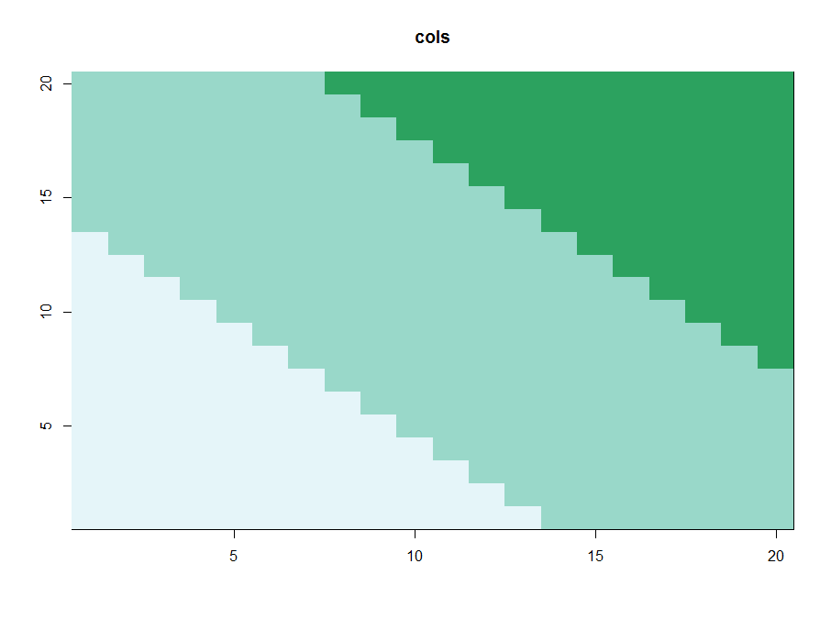

> pal <- colorRampPalette(cols)

| Perseverance, that's the answer.

|=================================================================================== | 83%

| The call showMe(pal(3)) would be identical to the showMe(cols) call. So use showMe to look at pal(20).

> showMe(pal(20))

| You got it!

|===================================================================================== | 84%

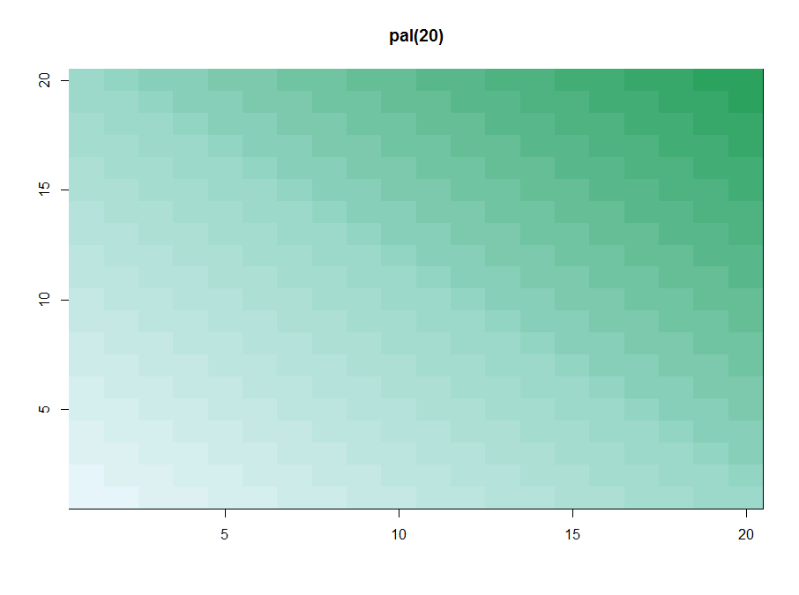

| Now we can use the colors in pal(20) to display topographic information on Auckland's Maunga Whau Volcano. R

| provides this information in a matrix called volcano which is included in the package datasets. Call the R

| function image with volcano as its first argument and col set equal to pal(20) as its second.

> image(volcano, col = pal(20))

| You are doing so well!

|====================================================================================== | 86%

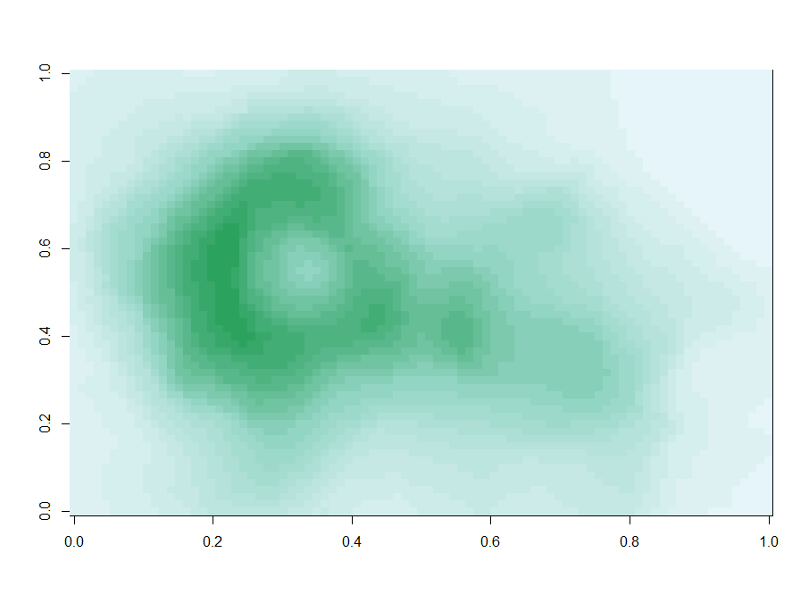

| We see that the colors here of the sequential palette clue us in on the topography. The darker colors are

| more concentrated than the lighter ones. Just for fun, recall your last command calling image and instead of

| pal(20), use p1(20) as the second argument.

> image(volcano, col = p1(20))

| All that hard work is paying off!

|======================================================================================== | 87%

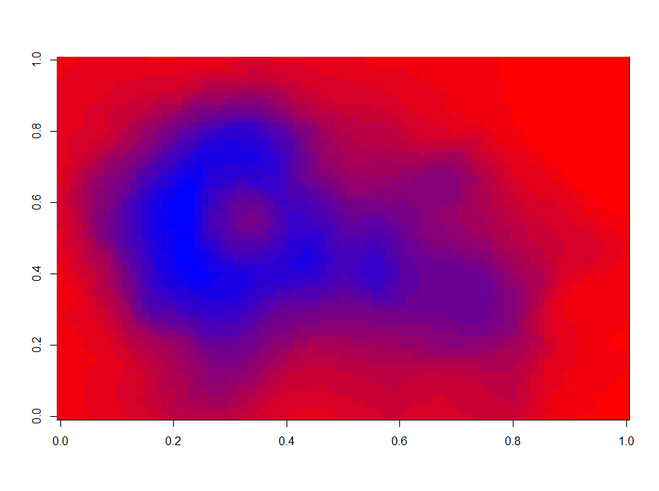

| Not as nice a picture since the palette isn't as well suited to this data, but that's okay. It's review

| time!!!!

...

|========================================================================================= | 88%

| True or False? Careful use of colors in plots/maps/etc. can make it easier for the reader to understand what

| points you're trying to convey.

1: True

2: False

Selection: 1

| Keep up the great work!

|=========================================================================================== | 90%

| Which of the following is an R package that provides color palettes for sequential, categorical, and

| diverging data?

1: RColorVintner

2: RColorBrewer

3: RColorBluer

4: RColorStewer

Selection: 2

| Keep working like that and you'll get there!

|============================================================================================ | 91%

| True or False? The colorRamp and colorRampPalette functions can be used in conjunction with color palettes

| to connect data to colors.

1: True

2: False

Selection: 1

| That's a job well done!

|============================================================================================== | 93%

| True or False? Transparency can NEVER be used to clarify plots with many points

1: False

2: True

Selection: 1

| You are really on a roll!

|=============================================================================================== | 94%

| True or False? The call p7 <- colorRamp("red","blue") would work (i.e., not generate an error).

1: True

2: False

Selection: 2

| All that practice is paying off!

|================================================================================================= | 96%

| True or False? The function colors returns only 10 colors.

1: True

2: False

Selection: 2

| Great job!

|================================================================================================== | 97%

| Transparency is determined by which parameter of the rgb function?

1: alpha

2: gamma

3: delta

4: beta

5: it's all Greek to me

Selection: 1

| Perseverance, that's the answer.

|==================================================================================================== | 99%

| Congratulations! We hope this lesson didn't make you see red. We're green with envy that you blue through

| it.

...

|=====================================================================================================| 100%